English CV
Shimaa Salah Abd elmonem Alsayed
Assistant lecture of Anatomy& Embryology
Faculty of Medicine, Benha University

Personal data

Name (Arabic) | شيماء صلاح عبدالمنعم السيد
Name (English) | Shimaa Salah Abd elmonem Alsayed
Department | Anatomy& Embryology
College | Faculty of medicine
Academic degree | Assistant lecturer of human anatomy& embryology
Office Address | Benha faculty of medicine
Mobile 1 | 01061505639
Email (university) | Shimaa.azab@fmed.bu.edu.eg  Shimaa20191860@gmail.com
Email (alternative)
Recent Photo (passport format) | 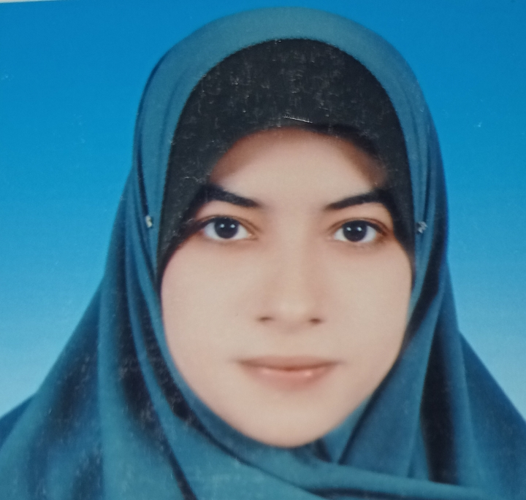

Education
Institution | Degree obtained | Year
Benha university  Faculty of medicine | Bachelor of medicine &general surgery  Master's degree of anatomy and embryology | 2013  2021

General specialty | Anatomy &Embryology

Language skills (Excellent, Very Good, Good, Basic)
Language | Reading | Speaking | Writing
Arabic | Excellent | Excellent | Excellent
English | Excellent | Excellent | Excellent

Positions
 | Date  From - to | Organization | Country | Position | Role
1 | March 2014 to March 2015 | Benha Faculty of Medicine Hospital | Egypt | House Officer | Training in different medical clinical branches
2 | April 2014to October 2015 | Egyptian Ministry of Health | Egypt | General practitioner
3 | October 2015 to March 2021 | Benha Faculty of Medicine | Egypt | Demonstrator in anatomy & embryology Department | Teaching  Research
4 | March 2021 till now | Benha Faculty of Medicine | Egypt | Assistant lecturer | Teaching  Research
List of Publications
Eid, E. M., Sarg, N. A., Mousa, H. R., & Abdelmonem, S. S. (2021). Angiographic Study of Normal Variations of Coronary Arteries in Normal Egyptian Persons. Benha Journal of Applied Sciences, 6(2), 71-77.‏.
Academic:
Clinical courses to the undergraduate students in
Upper limb, Abdomen & pelvis, Thorax, Head, Neck, Lower limb& Neuroanatomy.
Using data show slides , Jars , Models as descriptive tools inside section rooms
Other activities inside the department;
Dissection & preparation of specimens in jars
Arrangement of the models & jars in the anatomy museum
Areas of research:
- Growth & development
- Embryology & Teratology
- Gross anatomy
- Morphometry
- Radiological anatomy
Additional information :
1-International computer Driving License ICDLCertificate
2-digital transformation Certificate
3-toefl Certificate

